Dr. Matthew Ryan Smith   
733 Yeremi Street  
Pickering, ON Canada  
L1W2W8

[msmith@faculty.ocadu.ca](mailto:msmith@faculty.ocadu.ca)

**Indian Group of Seven Word Count 500**

The Indian Group of Seven is an ironic title given by a reporter from the *Winnipeg Free Press* to a collective of Indigenous artists from Canada, including Jackson Beardy (1944-1984), Eddy Cobiness (1933-1996), Alex Janvier (b. 1935), Norval Morrisseau (1932-2007), Daphne Odjig (b. 1919), Carl Ray (1942-1978), and Joseph Sanchez (b. 1948). Their name is a direct reference to the Group of Seven, a collective of Canadian artists who used the Canadian landscape as their primary subject matter in the 1920s and 1930s. The Indian Group of Seven emerged soon after Montreal’s 1967 International and Universal Expositionand the 1969 release of the Statement of the Government of Canada on Indian policy, events that were heavily criticised for supporting colonial legacies and supressing Indigenous rights. The Group’s artwork reacted against such politics. They sought to break cultural and political stereotypes by demanding recognition as artist professionals, by challenging established meanings of contemporary Indigenous art, and reconsidering social relationships to Indigenous peoples. Of central importance to their legacy, the Indian Group of Seven helped to change the preconceived notion that Indigenous artists are preoccupied with traditional craftwork such as weaving, pottery, and carving.

In 1973 members Beardy, Janvier, and Odjig were included in a group exhibition at the Winnipeg Art Gallery called *Treaty Numbers 23, 287, 1171*, a title referring to the numbered treaties of their bands. The exhibition was received as a critical success and helped establish other Indigenous artists as an influential voice in contemporary Canadian art discourse. In 1974 the seven artists who would eventually be recognized as the Indian Group of Seven assembled in Odjig’s home as a first step in legally incorporating their group as the Professional Native Indian Artists Incorporated (PNIAI). Though they did not release an official manifesto, the PNIAI was primarily concerned with supporting Indigenous artists and the communities they live in through advisement, discussion, and teaching. In their support of emerging Indigenous artists in Canada, they created a legacy of artistic excellence in Indigenous Canadian artists, such as Shirley Cheechoo, Blake Debassige, and Martin Panamick. While the Indian Group of Seven is often closely connected to the “Woodland Style”—an Ojibway visual language commonly associated with strong black lines, vivid colour palettes, and x-ray viewpoints—the subject matter and style of each member in the group is relatively distinct and divergent. The last exhibition featuring all seven members was held at the Dominion Gallery in Montreal in 1975; however a retrospective of their work and legacy organized by the MacKenzie Art Gallery, Regina will open in 2014.

**References and further reading**

Bailey, Jan and Morgan Wood. (2005) *Daphne Odjig: Four Decades of Prints*. Kamloops: Kamloops Art Gallery 2005.

Hill, Greg, et. al. (2006) [*Norval Morrisseau: Shaman Artist*.](http://search.library.utoronto.ca/details?5823308&uuid=53b2f7a9-8d7f-467a-af6d-503cdc71d646) Ottawa: National Gallery of Canada, 2006.

Hughes, Kenneth. (1979) *The Life and Art of Jackson Beardy*. Winnipeg: Canadian Dimension Publishers.

MacKenzie Art Gallery, http://www.mackenzieartgallery.ca/engage/exhibitions/7 (Accessed 27 February, 2014).

Martin, Lee-Ann and Robert Houle. (1993) *The Art of Alex Janvier: His First Thirty Years*, *1960-1990*. Thunder Bay: Thunder Bay Art Gallery.

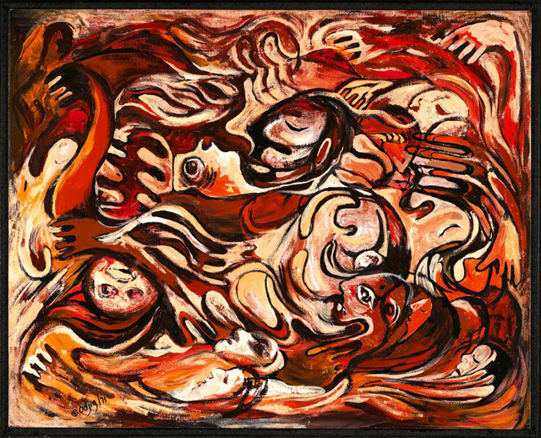

*Genocide No. 1*

Daphne Odjig

1971

61 x 76 cm  
acrylic on board  
Purchased 2001  
National Gallery of Canada (no. 40766)

http://www.gallery.ca/en/see/collections/artwork.php?mkey=98926

[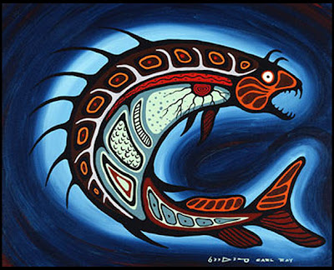](http://3.bp.blogspot.com/-ZjU_I38Rv_Q/UEDKd0xW0VI/AAAAAAAAAXU/h3u7LGizUfw/s1600/Carl_Ray_Spirit+Fish_24x30_1975.jpg)

Carl Ray, *Spirit Fish*, 1975.

Sandy Lake First Nation, Ontario, 1942 – 1978

Acrylic on canvas

61.4 x 76.7 cm

Purchased 1975

McMichael Canadian Art Collection (1975.32.2)

[info@mcmichael.com](mailto:info@mcmichael.com)

<http://www.mcmichael.com/privacy.cfm>

<https://mcmichael.com/exhibitions/legends/current.cfm>